Summer Internship Project Report
On

MULTIPLE DISEASE PREDICTION USING ML AND DL
Submitted in partial fulfillment of the requirement for the award of the degree of bachelor of technology
In

ELECTRONICS AND COMMUNICATION ENGINEERING
By

JAMAL AHAMMAD SHAIK-(O200272)

Under the Guidance of

MS. G VIJAYA KUMARI

Assistant Professor


Department of Electronics and Communication Engineering

RAJIV GANDHI UNIVERSITY OF KNOWLEDGE TECHNOLOGIES -AP ONGOLE CAMPUS

Kurnool Road, ONGOLE, Prakasam Dt, AndhraPradesh-523225

CERTIFICATE

This is to certifiy that the project entitled "MULTIPLE DISEASE PREDICTION USING ML AND DL" being submitted by JAMAL AHAMMAD SHAIK( 0200272) in the partial fulfillment of therequirementsfortheendsemesterlabexamandawardofthedegreeoftheBachelorof Technology in Electronics and communication Engineering to rajiv Gandhi University of Knowledge Technologies-AP, Ongole campus. Is a bonafide work carried out by them under my guidance and supervision The result presented in this project have been verified and found to be satisfactory the results emboidied in this project report have not been submitted to any university for the award of any other degree of diploma .

MS.G VIJAYA KUMARI Mr .VIJAYA BHASKAR
Assistant professor, Head Of Department
RGUKT Ongole. ECE

RGUKT, ONGOLE

ACKNOWLEDGEMENT

It is our privilege and pleasure to express a profound sense of respect, gratitude and in-debtdness to our guide Ms. G Vijaya Kumari, Assistant Professor ,Dept of Electronics and communication Engineering, Rajiv Gandhi University of Knowledge Technologies, for his/her indefatigable inspiration, guidance, cogent discussion, constructive criticisms and encouragement throughout this dessertation work. We express our sincere gratitude to Mr. VIJAYA BHASKAR Hod (i/c)- ECE for his suggestions, motivation and co- operation for the successful completion of the work. We extend our sincere thanks to Dr. A V S S KUMARA SWAMI GUPTA Director, RGUKTAP, ONGOLE CAMPUS for his encouragement.

JAMALAHAMMAD SHAIK -(O200272)

APPROVAL SHEET

This report titled “MULTIPLE DISEASE PREDICTION USING ML AND DL” submitted by JAMAL AHAMMAD SHAIK (O200272) Is approved for the award of The degree of bachelor technology in Electronics and communication Technology.

Examiner(s)

Supervisor

Date of submission:
Place of submission :
Mr.M.vijaya Bhaskar
Head of Department
Electronics and Communication

Stamp of department

DECLARATION
We here by declare that the project work entitles "MULTIPLE DISEASEPREDICTION USING ML AND DL "submitted to the Rajiv Gandhi University of Knowledge Technologies A.P.ONGOLE campus in partial fulfilment of the requirement for the summer internship report in Electronics and communication Engineering is a record of an original work done by us under the guidance of Ms.G VIJAYA KUMARI ,Assistant Professor(c) , Dept, of Electronics and communication Engineering and this project work have not been submitted to anyuniversityfortheawardof anyother degree or diploma.

JAMALAHAMMAD (O200866)

ABSTRACT
The"MultipleDiseasePredictionUsingMLandDL"project aimstoMultiplediseasepredictionleveragespatientdata, such as demographics, medical histories, lab results, and geneticinformation,topredicttheriskofvariousdiseases, often simultaneously. This study explores the integration of ML and DL techniques to develop a comprehensive predictive model that can identify multiple diseases, including but not limited to diabetes, cardiovascular diseases, and cancer.
We employ a range of ML algorithms, including decision trees, support vector machines (SVM), and random forests, along side DL architectures like convolutional neural networks (CNNs) and recurrent neural networks (RNNs), to process structured and unstructured data.DL methods, in particular, enable automatic feature extractionfromcomplexdatatypes,enhancingprediction accuracy and scalability. We compare the performance of the semodelson both balanced and imbalanced datasets to mimic real-world clinical scenarios, assessing their accuracy, sensitivity, and specificity for each target disease.

Our findings demonstrate that combining ML and DL can improve prediction accuracy for complex, multi-disease scenarios. This research underscores the value of advanced data processing and model selection in developingarobust,multi-diseasepredictionsystem,with the ultimate goal of aiding clinicians in early detection, improvingpreventivehealthcare,andoptimizingresource

allocation in clinical settings. The proposed model holds promiseasapracticaltoolforenhancingpatientoutcomes and advancing predictive healthcare.
Thesummary is thestudydevelopsamulti-diseaseprediction model using machine learning (ML) and deep learning (DL) to diagnose multiple diseases, like diabetes and cardiovascular conditions,basedonpatientdata.Byleveragingalgorithmssuch asdecisiontrees,SVM,andneuralnetworks,themodelaimsto achieve high accuracy and scalability. DL techniques enhance feature extraction, especially from complex data types, boosting overall prediction precision. The research highlights the potential of ML and DL in early disease detection, supporting preventive healthcare and resource optimization. This model could significantly aid clinicians in proactive patient management.

 | CONTENT
S.NO | TITLE | PAGENO
1. | INTRODUCTION | 09
- MOTIVATION
- PROBLEMDEFINITION
- OBJECTIVEOFTHEPROJECT

- LITERATUREREVIEW&ANALYSIS 12
- 1.EXISTINGSYSTEM 13
  - PROPOSEDSYSTEM
3 SOFTWAREREQUIREMENTSPECIFICATION
- DESIGN 15
  - UML DIAGRAMS
- IMPLEMENTATION 29
  - MODULES
  - MODULESDESCRIPTION
  - INTRODUCTIONOFTECHNOLOGIESUSED
  - SAMPLECODEANDOUTPUT
- TESTING 57
  - UNITTESTING
- CONCLUSION 58
- FUTUREENHANCEMENT 59
- BIBLIOGRAPHY 60

INTRODUCTION
Thehealthcare industryisrapidlyevolvingwiththe integrationofadvanced technologies

thatcanenhancepatient care, disease management,andpreventivestrategies. Amongthesetechnologies,machinelearning(ML)anddeeplearning(DL)have shownexceptionalpromiseinpredictingdiseasesbyanalyzingvastamountsof data. Traditionally, clinical diagnosis has relied on physical examinations, labtests,and imaging studies, but these methodsareoftentime-consuming, resource-intensive, and limited to single-disease identification.

ThisMultipleDiseasePredictionpredictsdifferenttypesofdiseaseslike

- HeartDiseasePrediction
- DiabetesDiseasePrediction
- ParkinsonDiseasePrediction
- CardioDiseasePrediction
- MedicalExpensesRegression

Multiplediseasepredictionisacrucialareainpredictiveanalyticsasit allows for early

detectionofseveraldiseasesatonce,enablingtimelyinterventionsand personalizedhealthcarestrategies.Diseasessuchasdiabetes,cardiovascular conditions,and various cancers share overlapping riskfactors, symptoms, andpatientdemographics,makingthemidealcandidatesforaunifiedpredictive approach.Byanalyzingstructureddata(e.g.,bloodtestresults,medicalhistory) andunstructureddata(e.g.,medicalimages,clinicalnotes),MLandDLmodelscanidentifycomplexpatternsandcorrelationsthatmightotherwisego unnoticed.

Machinelearningtechniqueslikedecisiontrees,randomforests,andsupport vectormachinesarewell-suitedforstructureddataandhavebeenwidely

used in predictive modeling .However , deep learning methods ,such as convolutional neuralnetworks (CNNs) and recurrent neural networks (RNNs), bring anew level of capability to process large and complex datasets, especiallyunstructured data like images and sequences. These DL models automatically learnimportant features without manual intervention, enhancing the prediction quality and expanding the scope of disease prediction across various domains.

Thisdocumentationexploresthemethodology,modelarchitecture,data preprocessing,andevaluationtechniquesemployedinbuildingarobust multiple disease prediction system. By combining MLand DL approaches, weaimtocreateamodelthatcangeneralizeacrossdifferentdiseasesanddatasets, supportingclinicianswithactionableinsightsforearlydiagnosis.Suchasystemhas the potentialto transformhealthcare by improving diagnostic accuracy, reducing healthcare costs, and ultimately enhancing patient outcomes. This documentservesasacomprehensiveguide forunderstandingthe development process,applications,andlimitationsofmulti- diseasepredictionsystemsusingMLandDL,emphasizingtheirroleinthe future of personalized medicine.

MOTIVATION
The motivation for developing multiple disease prediction models using machine learning (ML) and deep learning (DL) stems from the growing need for efficient,accurate,andcomprehensivediagnostic tools inhealthcare.Astheglobalpopulationagesandchronic diseases like diabetes, cardiovascular disorders, and cancer become more prevalent, early diagnosis and preventive care have become crucial to improving patient outcomes and reducing healthcare costs.

PROBLEMDEFINITION

The challenge in healthcare today is to predict multiple diseases simultaneously based on a patient's available data. Traditional diagnostic methods are generallydisease-specificandoftenrequireseparatetests or processes to diagnose eachcondition. However ,many diseases share commonrisk factors, symptoms, and patient demographic attributes, making it possible to predict them concurrently through advanced machine learning (ML) and deep learning (DL) methods.

OBJECTIVEOFTHEPROJECT
The objective of this study is to design and implement a predictive model using machinelearning(ML)anddeeplearning(DL)techniquesthatcanaccuratelyforecastthe likelihood of multiplediseases based on patient data. Specifically, the goals are as follows:

- SimultaneousMulti-DiseasePrediction:Developamodelcapableof predictingmultiplediseasesatonce,enablingaholisticapproachtopatient diagnosis and management. This will address the need for proactive, integrated health care that conside rstheinterrelated nature fmany chronic conditions, such as cardiovascular disease, diabetes, and cancer.
- Data Integration and Processing: Combine and process structured data (like demographic details, lab results, and medical histories) and unstructured data (like clinical notes and medical images) to achieve a comprehensive view of thepatient.Thisintegrationaimstoenhancethepredictivepowerofthemodelby utilizing all relevant data types.
- PatternRecognitionAcrossDiseases:UtilizeMLandDLmethodsto identify hidden patterns ,correlations, and shared risk factors across various diseases,especiallythosewithoverlappingsymptomsandriskfactors.This willenablethe modelto make moreaccuratepredictionsandrecognize co- morbidities, which can be critical for effective patient care.
- HandlingDataImbalances:Createamodelresilienttotheimbalancednature of medical data, where certain diseases may be underrepresented. This is important to ensure fair and accurate predictions across differentconditions, even if they are rare or less frequently diagnosed

LITERATURESURVEY

MachineLearningTechniquesinMultipleDiseasePrediction

  - SupervisedLearning:Widelyusedfordiseaseprediction,withmodelslike Logistic Regression,Decision Trees, Random Forests,Support Vector Machines (SVM), and K-Nearest Neighbours.
    - Example:SVMsandRandomForestshavebeenusedtopredict diseaseslikediabetes,cardiovasculardiseases,andliverconditions with a single input dataset of features.
  - EnsembleLearning:CombiningmultipleMLmodels(e.g.,bagging, boosting) toimproveaccuracy.EnsemblemethodslikeGradientBoostingandXGBoost are effective in reducing false negatives for disease prediction.
    - Example:GradientBoostingmodelsareusedinpredictingchronic diseases by aggregating predictions from multiple decision trees, which helps capture more complex patterns in patient data.

DeepLearningApproachesinDiseasePrediction

  - Neural Networks: Multilayer Perceptrons(MLPs)are the most basic type ofDLmodelandareoftenappliedwhendataisstructuredandrelatively low- dimensional.
  - Convolutional Neural Networks (CNNs): Primarily used in medical imaging(e.g.,X-rays,MRIs)fordiseaseslikecancer,pneumonia,andCOVID-
19.CNNsarehighlyeffectiveinidentifyingfeaturesinspatialdata.
  - Recurrent Neura lNet works (RNNs) and Long Short-TermMemory Networks(LSTMs):Usedfortime-series data,suchas ECG or continuous glucosemonitoring.Thesemodelshandlesequentialdataeffectivelyand are often applied in diseases requiring tracking over time, like cardiac conditions and diabetes.

Multi-DiseasePredictionModels

  - Multi-LabelClassification:Predictsmorethanonediseasefromasingle modeloutput.Methodsincludeextendingbinaryclassificationalgorithmsor using deep architectures with multiple output nodes.
    - Example:UsingaCNN-basedmodelforpredictingbothpneumonia and tuberculosis from chest X-rays.

ANALYSIS

ExistingSystem
  - Overview: Describe the traditional approaches currently in use for disease prediction,whichmayincludeindividualmodelsforeachdisease,relianceon manual diagnosis, or basic statistical methods.

Limitations:
    - SeparateModels:Existingsystemsmightrequireseparatemodelsfor each disease, which increases complexity and computational requirements.
    - DataFragmentation:Traditionalsystemsmaystruggletointegrate various data types (e.g., imaging, EHR, sensor data) into one prediction framework.
    - Scalability:Mostcurrentsystemsarenotdesignedtohandlemultiple diseases simultaneously or lack adaptability to new diseases.
    - AccuracyandInterpretability:Oldermodelsmayhaveloweraccuracy and are often “black-box” models, offering limited interpretability which is critical in healthcare.
  - UseCases in Industry:Mentionanyprominentsystems(e.g.,IBMWatson Health)orplatforms usedfordiseasepredictionandtheir featuresand shortcomings.

ProposedSystem
  - Objective:Outlinethepurposeoftheproposedmultiplediseaseprediction model, including goals such as improved accuracy, efficiency, and comprehensive disease analysis.

Architecture:
    - Multi-DiseaseModel:Aunifiedmodelorensemblecapableof predicting multiple diseases simultaneously.
    - DataIntegration:Abilitytohandlediversedatainputs(structured, unstructured, and time-series) to make more holistic predictions.
    - HybridApproach:Acombinationofmachinelearninganddeep learningmodels(e.g.,CNNforimaging,LSTMfortime-seriesdata)to handle different data types and disease predictions within one system.

Advantages:

    - IncreasedEfficiency:Reducestheneedforseparatediagnostictools for each disease.
    - Scalability:Easilyadaptedtoincludenewdiseasesoradditional datasets as they become available.
    - Improved Accuracy and Interpretability:UsesadvancedML/DL techniques and interpretablemodelsforhigheraccuracyandtransparency in predictions.

SoftwareRequirementSpecification(SRS)

FunctionalRequirements:
    - DataInputModules:Interfacetoinputdifferenttypesofdata(e.g., imaging, EHR, sensors).
    - PredictionEngine:CoremodulewhereML/DLmodelsanalyzeand predict multiple diseases based on inputs.
    - InterpretabilityModule:Providesinsightsintohowpredictionsare made, aiding clinicians in understanding model decisions.
    - Reporting and Visualization:Generatesreportsandvisualizespredictions to support clinical decisions.

Non-FunctionalRequirements:
    - Performance:Themodelshouldperformreal-timeornear-real-time predictions, depending on the use case.
    - ReliabilityandAccuracy:Ahighdegreeofaccuracyiscrucial,withlow false negatives/positives for clinical safety.
    - SecurityandPrivacy:Ensuringthatpatientdataishandledsecurely, meeting standards like HIPAA or GDPR.

SoftwareandHardwareRequirements:
    - Software:
      - ProgrammingLanguages:PythonorR(forML/DLframeworks).
      - Libraries:TensorFlow,PyTorch,Scikit- learn,Pandas,NumPy, etc.
      - DataHandling:ApacheSparkorSQLforlargedatasets,where applicable.
      - Visualization:Matplotlib,Seaborn,orDashforresult visualization.

Hardware:
      - Processor:GPU(NVIDIACUDAsupport)fordeeplearning model training.

      - Memory:Minimumof16GBRAM,scalabletomeetdata processing needs.
      - Storage:Amplestoragetohandlelargemedicaldatasets.

DESIGNUML DIAGRAMS
A UML Diagram is based on UML(Unified Modeling Language)withthepurposeofvisuallyrepresentingasystem along with itsmain actors, roles, actions, artifactsor classes, in order to better understand, alter, maintain ,or document information about the system. The UML diagrams are divided into Structural and Behavioural UML Diagrams.

STRUCTURALUMLDIAGRAMS:
Structural diagrams depict a static view of a structure of a system.It is widely used in the Documentation of software architecture.TheStructuralUMLDiagramsinvolves6diagrams. They are .
- Class Diagram
- ObjectDiagram
- ComponentDiagram
- CompositeDiagram
- PackageDiagram
- DeploymentDiagram
- ProfileDiagram

BEHAVIOURALUMLDIAGRAMS:
Behavioural diagram spotray adynamic viewof asystem or the behaviour of a system which describes the functioning the system. It involves diagrams They are:
- UseCaseDiagram
- StateMachineDiagram
- CommunicationDiagram
- SequentialDiagram

CLASSDIAGRAM

The class diagram is the main building block of object- oriented modeling. It is used for general conceptual modeling of the structure of the application, and for detailed modeling translating the models into programming code. Class diagrams can also be used for data modelling.

OBJECTDIAGRAM
Itdescribesthestaticstructureofasystemataparticularpoint in time. It can be used to test the accuracy of class diagrams. It represents distinct instances of classes and the relationship between them at a time.
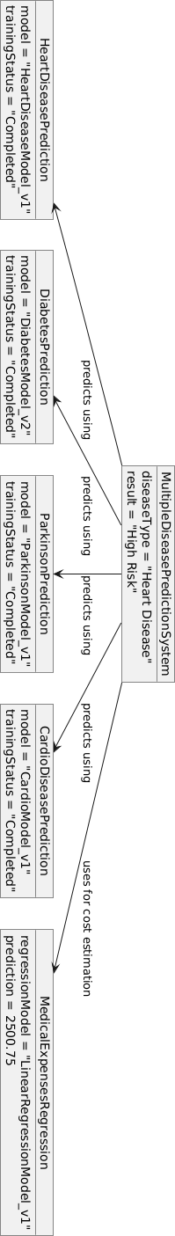

COMPONENTDIAGRAM
Componentdiagramsareusedinmodelingthephysical aspects of objectoriented systems that are used for visualizing, specifying, and documenting component- based systems and also for constructing executable systems through forward and reverse engineering. Component diagrams are essentially class diagrams that focusonasystem'scomponentsthatoften usedtomodel the static view of diagram.

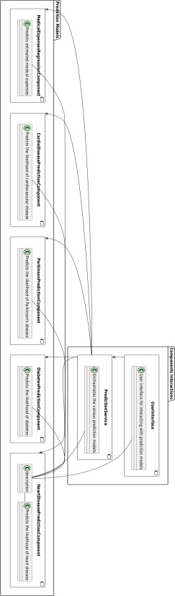

COMPOSITESTRUCTUREDIAGRAM
Composite Structure Diagram is one of the new artifacts added to UML 2.0. A composite structure diagram is a UML structural diagram that contains classes, interfaces, packages, and their relationships, andthat provides a logical viewofall,orpartofa software system.It shows the internal structure (including parts and connectors) of a structured classifier or collaboration.

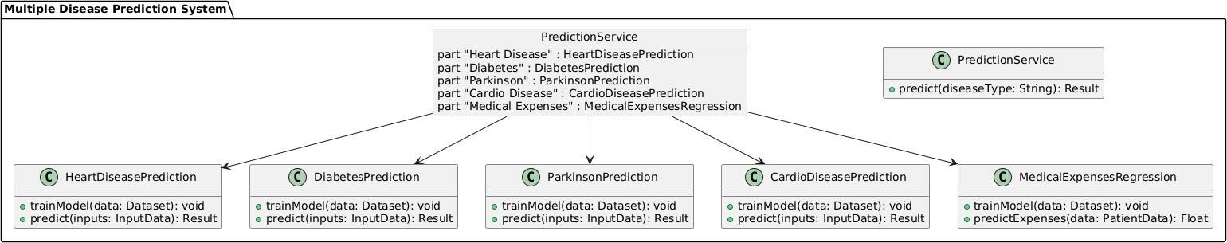

PACKAGEDIAGRAM
Packagediagramsareused,inpart,todepictimportandaccess dependenciesbetweenpackages,classes,components,and other named elements within your system. Each dependence isrenderedasaconnectinglinewithanarrowrepresentingthetype of relationship between the two or more elements.

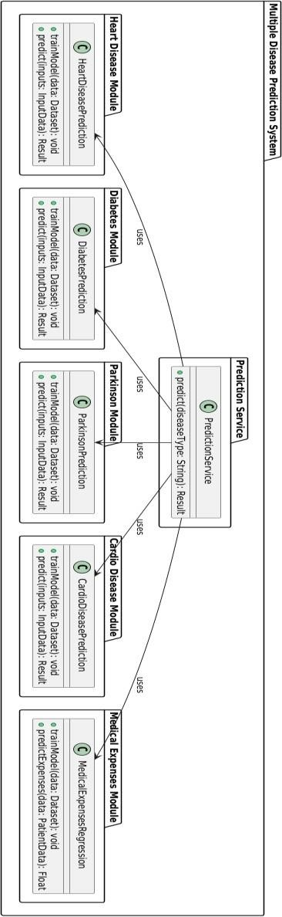

PROFILEDIAGRAM
Profile diagram is basically an extensibility mechanism that allows you to extend and customize UML by adding new building blocks, creating new properties and specifying new semantics in order to make the language suitable to your specific problem domain.

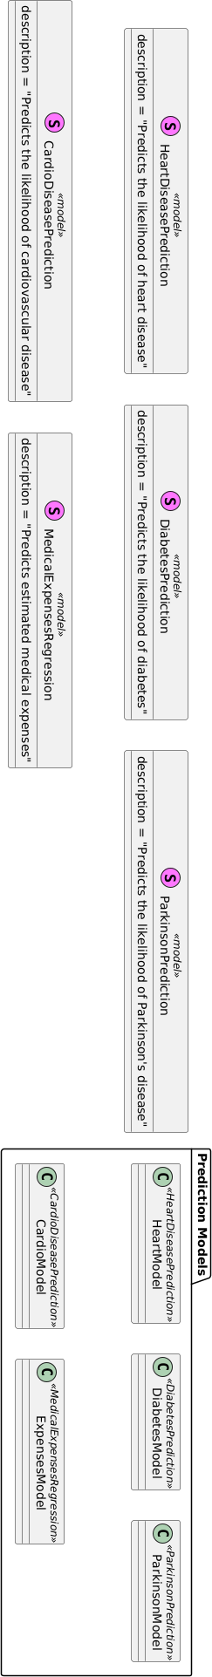

DEPLOYMENTDIAGRAM
Adeployment diagram is a UML diagramtypethatshowsthe execution architecture of a system, including nodes such as hardware or software execution environments, and the middleware connecting them. Deployment diagrams are typicallyusedtovisualizethephysicalhardwareandsoftware of a system.

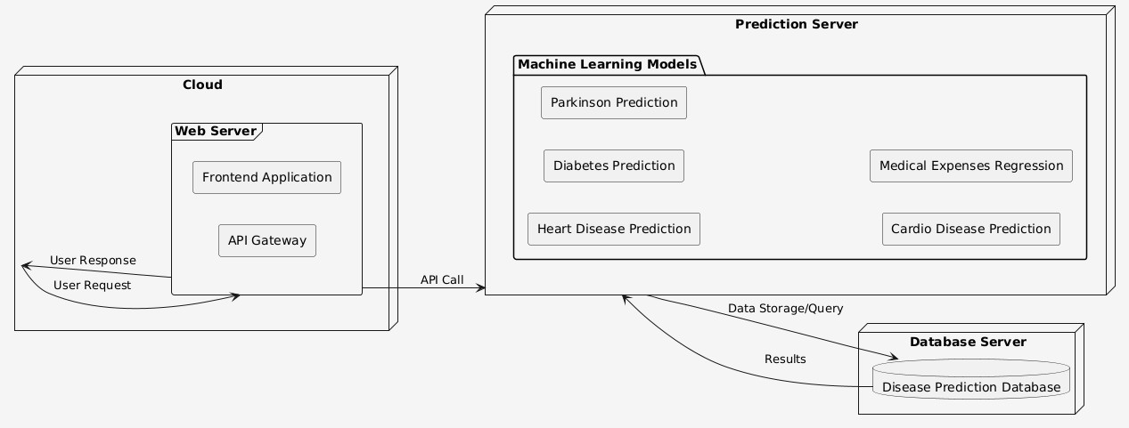

SEQUENTIALDIAGRAM
A sequence diagram consists of a group of objects that are representedby lifelines andthe messages that they exchange over time during the interaction. A sequence diagram shows thesequenceof messages passed betweenobjects. Sequence

Diagramscanalsoshowthecontrolstructuresbetweenobjects.

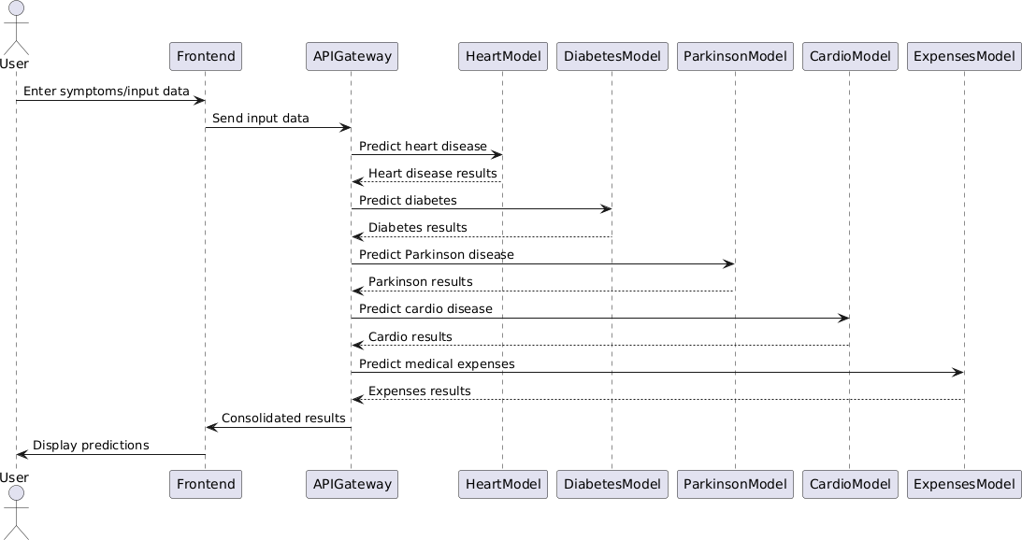

COMMUNICATIONDIAGRAM
A Communication diagram models the interactions between objects or parts in terms of sequenced messages. Communication diagrams represent a combination of informationtakenfromClass ,Sequence,andUseCaseDiagrams describing both the static structure and dynamic behav19r of a system.

STATEMACHINEDIAGRAM
A state diagram, also known as a state machine diagram or statechartdiagram,isanillustrationofthestatesanobjectcan attain as well as the transitions between those .ates in the Unified Modeling Language (UML).

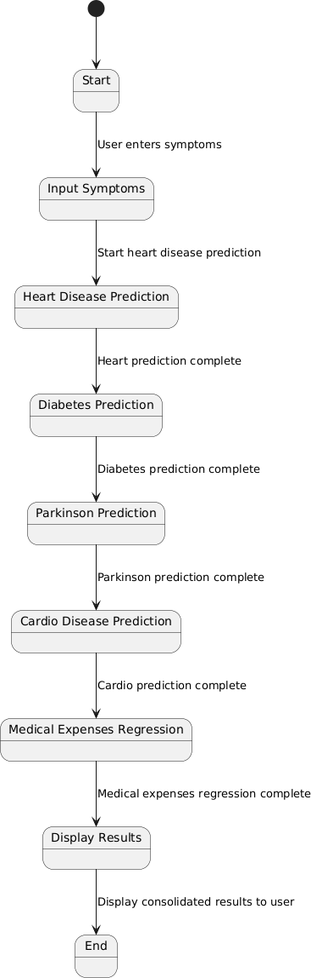

USECASEDIAGRAM
Use-casediagramsdescribethehigh-levelfunctionsandscope of a system. These diagrams also identify the interactions betweenthesystemanditsactors.Theusecasesandactorsin usecasediagramsdescribewhatthesystemdoesandhowthe actors use it, but not how the system operates internal.

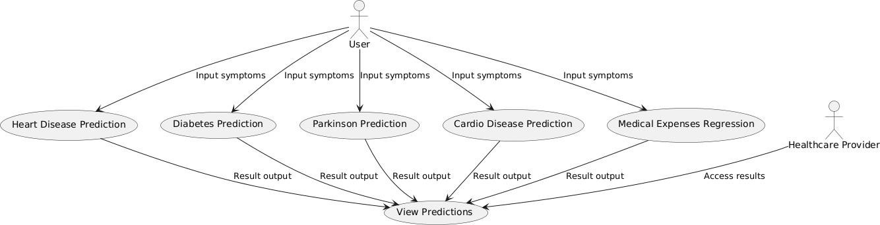

IMPLEMENTATION

1.MODULES:
  - Welcome/UserInterfacepage

  - HeartDisease Prediction

  - CardiovascularDiseasePrediction

  - Parkinson’sDiseasePrediction

  - DiabetesPrediction

  - Aboutpage

5.2.MODULEDESCRIPTION:
WelcomeorUserInterfacePage:
The User Interface module serves as the front-end component of the multiplediseasepredictionsystem,providinganaccessibleandintuitive interface for users to interact with various disease prediction tools.

HeartDiseasePrediction:

This model analyzes patient data, such as age, blood pressure, cholesterol levels, and lifestyle habits, to estimate the risk of heart disease.Byidentifyinghigh-riskindividuals,itaidsinearlyinterventionand personalized treatment plans, potentially lowering the likelihood of heart attacks or related complications.

CardioDiseasePrediction:

Focused on cardiovascular health, this model assesses risk factors like BMI,smokingstatus,bloodpressure,andexercisehabits.Itpredictsthe likelihood of cardiovascular diseases, supporting preventive measures and personalized health guidance to manage heart health proactively.

DiabetesPrediction:

Usingdatasuchasglucoselevels,bodymassindex,andfamilymedical history,thismodelpredictsthelikelihoodofdiabetes.Earlyprediction facilitates lifestyle adjustments and medical management, which are essential for maintaining healthy blood sugar levels and preventing diabetes complications.

Parkinson’sDiseasePrediction:

Thismodelleveragesmotorandvoicedataalongwithsymptoms like tremorsorslowedmovementtopredicttheriskofParkinson’sdisease. Early detectionsupportstimelytreatmentoptions,helpingto slowprogression and improve patients' quality of life.

Aboutpage:
In menu bar we can provide About page.here we have incxlude how to use our app efficiently and to use most of its features to solve real life problems related to image generation.

5.3INTRODUCTIONOFTECHNOLOGIESUSED:

PYTHON:

DataProcessingand Analysis:

PythonLibraries:Pandas,NumPy,SciPy(fordatamanipulation, analysis, and statistical operations)

MachineLearning&Modeling:

Algorithms:LogisticRegression,SupportVectorMachines(SVM), Random Forest,DecisionTrees,k-NearestNeighbors(KNN),Gradient Boosting, Neural Networks

Libraries: Scikit-Learn (for machine learningmodels), TensorFlow, Keras,andPyTorch(fordeeplearning,especiallyusefulforcomplex datasets)

ModelEvaluation:

Metrics: Accuracy, Precision, Recall, F1 Score, AUC-ROC (for evaluatingmodelperformanceandhandlingimbalanceddatasets)

Cross-ValidationTechniques:K-FoldCrossValidation,StratifiedK- Fold (to validate model generalizability)

FeatureEngineeringandScaling:

Techniques:StandardScaler,MinMaxScaler,PolynomialFeatures,PCA (Principal Component Analysis) for dimensionality reduction

Encoding:LabelEncoding,One-HotEncoding(forcategoricaldata)

DeploymentandIntegration:

WebFrameworks:Streamlit(tocreateinteractivewebappsfor predictions)

CloudServices:StreamlitCloud forhostedapplications

Welcome/UserInterfacePage:

SampleCode:
importpickle importstreamlitasst importnumpyasnp
fromstreamlit_option_menuimportoption_menu import tensorflow as tf fromtensorflowimportkeras

heart_model=pickle.load(open("/home/bunnys-weapon/MLweb apps/multiple disease prediction web app VERSION- 1/heart.sav","rb"))
diabetes_model=pickle.load(open("/home/bunnys-weapon/MLweb apps/multiple disease prediction web app VERSION- 1/diabetes_model.sav","rb"))

parkinson_model=pickle.load(open("/home/bunnys-weapon/MLweb apps/multiple disease prediction web app VERSION- 1/parkinson_model.sav","rb"))

cardio_model=tf.keras.models.load_model("/home/bunnys-weapon/MLweb apps/multiple disease prediction web app VERSION- 1/cardio_model.h5")
charges_model=tf.keras.models.load_model("/home/bunnys- weapon/ML web apps/multiple disease prediction web app VERSION- 1/charges_model.h5")

charges_scaler=pickle.load(open("/home/bunnys-weapon/MLweb apps/multiple disease prediction web app VERSION- 1/charges_scaler.sav","rb"))

parkinson_scaler=pickle.load(open("/home/bunnys-weapon/MLweb apps/multiple disease prediction web app VERSION- 1/parkinson_scaler.sav","rb"))

diabetes_scaler=pickle.load(open("/home/bunnys-weapon/MLweb apps/multiple disease prediction web app VERSION- 1/diabetes_scaler.sav","rb"))

cardio_scaler=pickle.load(open("/home/bunnys-weapon/MLweb apps/multiple disease prediction web app VERSION- 1/cardio_scaler.sav","rb"))

withst.sidebar:
selected=option_menu("MultipleDiseasePrediction",

["Heart Disease Prediction","Diabetes Prediction","Parkinson Prediction","CardioDiesasePrediction","Medicalexpensesregression"],

icons=["heart","activity","person","balloon-heart-fill","cash"],

default_index=0) ifselected=="HeartDiseasePrediction":def
pred_heart(inp):
inp = np.asarray(inp) inp=inp.reshape(1,-1) ans=heart_model.predict(inp) if ans == 0:
return"Noheartdisease"else: return"Clearsignsofheartdisease
st.title("HeartDiseasePrediction") col1,col2,col3=st.columns(3)
#Inputfields
withcol1:
age=st.text_input("Age") with col2:
sex=st.text_input("Gender") with col3:
cp=st.text_input("ChestPain") with col1:
trestbps=st.text_input("RestingBloodPressure") with col2:
chol=st.text_input("SerumCholestrol") with col3:

fbs=st.text_input("FastingBloodSugar") with col1:
restecg=st.text_input("RestingECGResults")with
col2:
thalach=st.text_input("MaximumHeartRateAchieved") with col3:
exang=st.text_input("Exercise-inducedAngina") with col1:
oldpeak=st.text_input("Oldpeak") with col2:
slope=st.text_input("Slope") with col3:
ca=st.text_input("NumberofMajorVessels(0-3)coloredby
fluoroscopy")
withcol1:
thal=st.text_input("Thalassemia") # Prediction and output
diagnosis=""
ifst.button("GetHeartDisease Prediction"): input_data=[int(age),int(sex),int(cp),int(trestbps),int(chol),
int(fbs),int(restecg),
int(thalach),int(exang),float(oldpeak),int(slope),int(ca),
int(thal)]
diagnosis=pred_heart(input_data) st.success(diagnosis)
ifselected=="DiabetesPrediction":

defpred_diabetes(inp):
inp=np.asarray(inp) inp=inp.reshape(1,-1) inp=diabetes_scaler.transform(inp
)
pred=diabetes_model.predict(inp)i f pred[0]==0:
return"Thepatientisnondiabetic"

else:
return"Thepatientisdiabetic"st.title("Diabetes Prediction") col1,col2,col3=st.columns(3)
withcol1:
Pregnancies=st.text_input("Pregnancies") with col2:
Glucose=st.text_input("Glucose") with col3:
BloodPressure=st.text_input("BP") with col1:
SkinThickness=st.text_input("SkinThickness"
)withcol2:
Insulin=st.text_input("Insulin") with col3:
BMI=st.text_input("BMI") with col1:

DiabetesPedigreeFunction=st.text_input("DiabetesPedigree
Function")
withcol2:
Age=st.text_input("Age") result="" ifst.button("DiabetesPrediction"):
inp=[ int(Pregnancies), int(Glucose),int( BloodPressure),int(SkinThickness) ,int(Insulin), float(BMI)
,float(DiabetesPedigreeFunction) ,int(Age)
]
result=pred_diabetes(inp) st.success(result)
if selected=="Parkinson Prediction": st.title("ParkinsonsDiseasePrediction") def pred_parkinson(inp):
inp=np.asarray(inp) inp=inp.reshape(1,-1) inp=parkinson_scaler.transform(inp) ans=parkinson_model.predict(inp)
ifans==0:

return"Thepersonisperfectlyhealthy"elif ans==1:
return"ThepersonishasParkinsonsDisease"col1,col2,col 3=st.columns(3)
withcol1:

MDVP_Fo_Hz=st.text_input("MDVP:Fo(Hz)")

withcol2:

MDVP_Fhi_Hz=st.text_input("MDVP:Fhi(Hz)") with col3:
MDVP_Flo_Hz=st.text_input("MDVP:Flo(Hz)") with col1:
MDVP_Jitter_percent=st.text_input("MDVP:Jitter(%)") with col2:
MDVP_Jitter_Abs=st.text_input("MDVP:Jitter(Abs)") with col3:
MDVP_RAP=st.text_input("MDVP:RAP") with col1:
MDVP_PPQ=st.text_input("MDVP:PPQ") with col2:
Jitter_DDP=st.text_input("Jitter:DDP") with col3:
MDVP_Shimmer=st.text_input("MDVP:Shimmer") with col1:
MDVP_Shimmer_dB=st.text_input("MDVP:Shimmer(dB)") with col2:
Shimmer_APQ3=st.text_input("Shimmer:APQ3") with col3:
Shimmer_APQ5=st.text_input("Shimmer:APQ5") with col1:
MDVP_APQ=st.text_input("MDVP:APQ") with col2:

Shimmer_DDA=st.text_input("Shimmer:DDA") with col3:
NHR=st.text_input("NHR") with col1:
HNR=st.text_input("HNR") with col2:
RPDE=st.text_input("RPDE") with col3:
DFA=st.text_input("DFA") with col1:
spread1=st.text_input("spread1") with col2:
spread2=st.text_input("spread2") with col3:
D2=st.text_input("D2") with col1:
PPE=st.text_input("PPE") answer="" ifst.button("Parkinsonsprediction"):
inp=[float(MDVP_Fo_Hz),float(MDVP_Fhi_Hz), float(MDVP_Flo_Hz),float(MDVP_Jitter_percent),
float(MDVP_Jitter_Abs),float(MDVP_RAP), float(MDVP_PPQ),
float(Jitter_DDP),float(MDVP_Shimmer),float(MDVP_Shimmer_dB),

float(Shimmer_APQ3),float(Shimmer_APQ5),float(MDVP_APQ), float(Shimmer_DDA),float(NHR),float(HNR),float(RPDE),float(DFA),floa
t(spread1),float(spread2),float(D2),float(PPE)]

answer=pred_parkinson(inp)

st.success(answer) ifselected=="CardioDiesasePrediction":
def pred_cardiovascular(inp): inp=np.asarray(inp) inp=inp.reshape(1,-1) inp=cardio_scaler.transform(inp
)
pred=cardio_model.predict(inp)i f pred[0]>0.5:
return"Thepatienthascardiacdisease"

else:
return"Thepatienthasnocardiacdisease"st.title("Cardiac Disease prediction") col1,col2,col3=st.columns(3)
withcol1:

Pregnancies=st.text_input("Age"
)withcol2:
Glucose=st.text_input("Gender") with col3:

BloodPressure=st.text_input("Height")

withcol1:
SkinThickness=st.text_input("Weight") with col2:
Insulin=st.text_input("ap_hi") with col3:
BMI=st.text_input("ap_lo") with col1:
DiabetesPedigreeFunction=st.text_input("Cholesterol") with col2:
Age=st.text_input("Glucose") with col3:
smoke=st.text_input("Smoke") with col1:
alcohol=st.text_input("Alcohol") with col2:
active=st.text_input("Active") result="" ifst.button("cardiovasularprediction"):
inp=[ int(Pregnancies), int(Glucose),int( BloodPressure),int(SkinThickness) ,int(Insulin), float(BMI)
,float(DiabetesPedigreeFunction) ,int(Age)
,int(smoke),int(alcohol),int(active)] result=pred_cardiovascular(inp)
st.success(result) ifselected=="Medicalexpensesregression":def
pred_medicalexpenses(inp):

if inp[1]=="male":
inp[1]=1 elifinp[1]=="female":
inp[1]=0

ifinp[4]=="yes":
inp[4]=1 elifinp[4]=="no":
inp[4]=0

ifinp[5]=="southeast": inp[5]=1
elifinp[5]=="southwest": inp[5]=2 elifinp[5]=="northeast": inp[5]=4 elifinp[5]=="northwest": inp[5]=3

inp=np.asarray(inp) inp=inp.reshape(1,-1) inp=charges_scaler.transform(inp
)
pred=charges_model.predict(inp) return pred

st.title("MedicalChargesPrediction")

col1,col2,col3=st.columns(3) with col1:
age=st.text_input("Age") with col2:
sex=st.text_input("Sex") with col3:
bmi=st.text_input("BMI") with col1:
children=st.text_input("Children") with col2:
smoker=st.text_input("Smoker") with col3:
region=st.text_input("Region") result="" ifst.button("medicalexpensesprediction"):
inp=[ int(age),sex,float(bmi),int(children),smoker,region] result=pred_medicalexpenses(inp)
st.success(result)

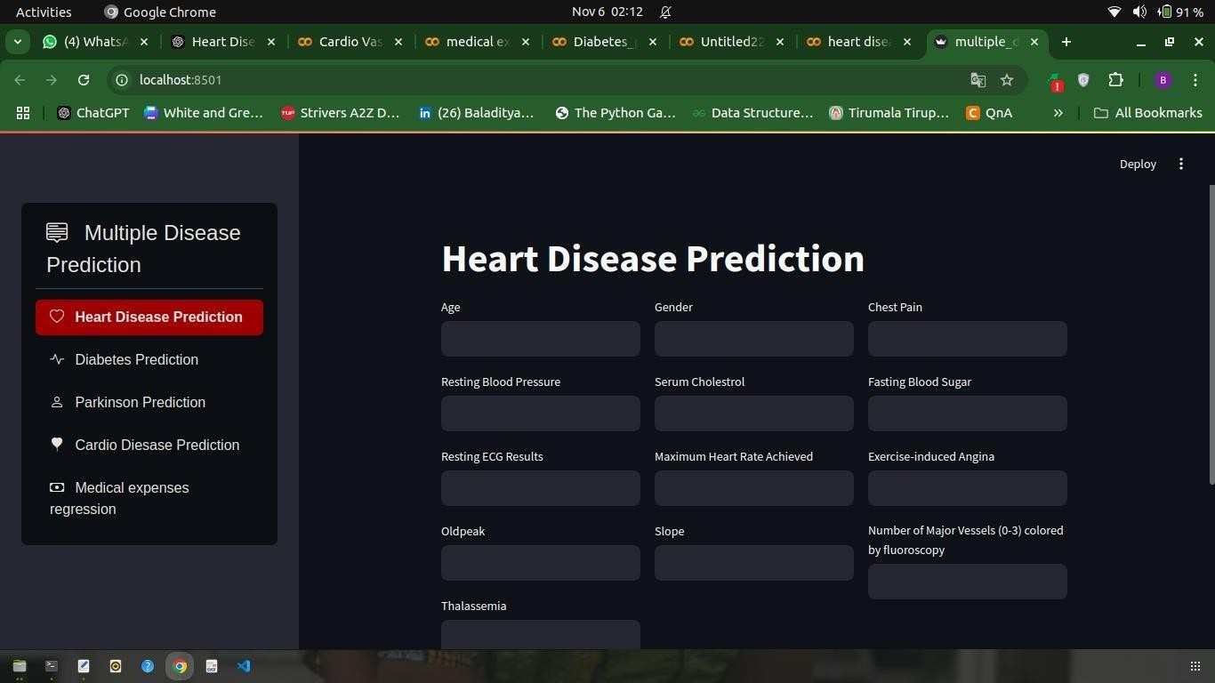

HeartDiseasePrediction:

SampleCode:
importnumpyasnp importpandasaspd
fromsklearn.model_selectionimporttrain_test_split fromsklearn.linear_modelimportLogisticRegressionfrom sklearn.metrics import accuracy_score data=pd.read_csv("/content/heart.csv")
data.head() data.shape data.tail() data.info() data.isnull().sum() data.describe()
data["target"].value_counts()

x=data.drop(columns="target") y=data["target"]
print(x) print(y)

x_train,x_test,y_train,y_test=train_test_split(x,y,stratify=y,random
_state=2,test_size=0.2) print(x.shape,x_train.shape,x_test.shape)

model=LogisticRegression() model.fit(x_train,y_train) train_pred=model.predict(x_train) test_pred=model.predict(x_test) train_acc=accuracy_score(train_pred,y_train
)test_acc=accuracy_score(test_pred,y_test) print(train_acc,test_acc)

def pred(input): input=np.asarray(input) input=input.reshape(1,- 1)
ans=model.predict(input) if ans==0: print("Noheartdisease") else:
print("clearsignsofheartdisease")

pred((62,0,0,138,294,1,1,106,0,1.9,1,3,2))
pred((71,0,0,112,149,0,1,125,0,1.6,1,0,2))
x.columns importpickle

file_name="heart.sav"

pickle.dump(model,open(file_name,'wb'))
Output:

DiabetesPrediction:

Samplecode:

importpandasaspd importnumpyasnp importseabornassns
fromsklearn.preprocessingimportStandardScaler from sklearn import svm
fromsklearn.model_selectionimporttrain_test_splitfrom sklearn.metrics import accuracy_score

Importandhaveanoverviewofthedata

diabetes=pd.read_csv("/content/diabetes.csv") diabetes.shape

diabetes.head()
#observethatallthevaluesinacolumnarenotinthesamerange

#0inoutcomeis-vefordiabetes #1inoutcomeis+vefordiabetes

diabetes.describe()

Obsevethedifferenceindifferentaspectsofthedatabygroupingit with targert variable i.e Outcome

diabetes.groupby("Outcome").mean() #observeinthemeanvalueofpregnenciesisgraterindiabeticpatients and same analogy #withglucode,BP,skinthicknessandInsulin.Sounderstandthat diabetes is #directlyproportionalwithallthesefeaturesComparingthe number of diabetes vs non-diabetes patients

diabetes["Outcome"].value_counts() sns.countplot(data=diabetes,x="Outcome") DividingthedataintofeaturesandOutcomestopredict
x=diabetes.drop(columns="Outcome",axis=1) y=diabetes["Outcome"]
print(x) print(y)

#Standardising the data so that all the values in all the columns in thedatawillbeinthesamerangewhichwillbeagreathelptothemachine

scaler=StandardScaler() scaler.fit(x) x=scaler.transform(x) print(x)
print(y)
#Splitting the data into Training and Tesing data x_train,x_test,y_train,y_test=train_test_split(x,y,random_sta
te=2,test_size=0.2,stratify=y) print(x.shape,x_train.shape,x_test.shape)

#Buildingthemodel

model=svm.SVC(kernel="linear") model.fit(x_train,y_train)

PredicingandFindingaccuracy

train_predicted=model.predict(x_train) train_score=accuracy_score(train_predicted,y_train
)print(train_score)

test_predicted=model.predict(x_test) test_score=accuracy_score(test_predicted,y_test) print(test_score)

#Functiontopredictforunknowninputs

def predict_new(input): input=np.asarray(input) input=input.reshape(1,-1) input=scaler.transform(input
)pred=model.predict(input) if pred[0]==0:
print("Thepatientisnondiabetic")else: print("Thepatientisdiabetic")

predict_new([0,137,40,35,168,43.1,2.288,33]) predict_new([3,126,88,41,235,39.3,0.704,27])

Output:

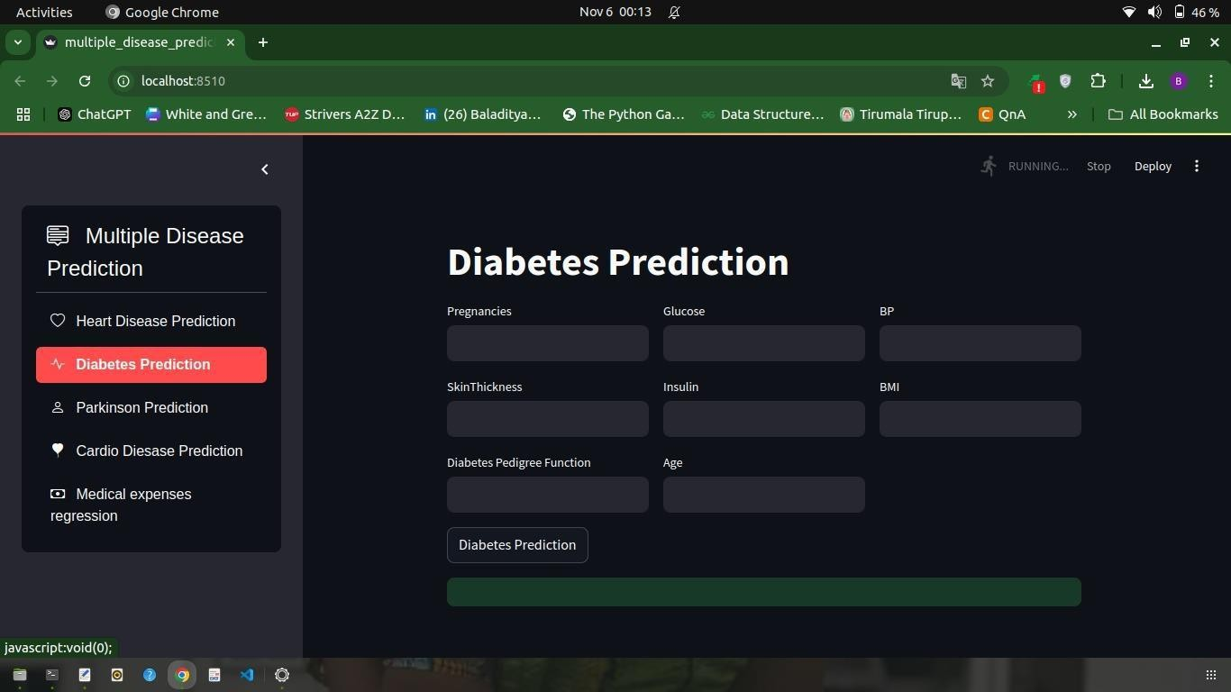

ParkinsonPrediction:

Samplecode:
import pandas as pd import numpy as np fromsklearnimportsvm
fromsklearn.metricsimportaccuracy_score fromsklearn.model_selectionimporttrain_test_splitfrom sklearn.preprocessing import StandardScaler

data=pd.read_csv("/content/parkinsons.csv") data.head()

data.shape data.isnull().sum() data.describe()

data.info() data.drop(columns="name",axis=1).groupby("status").mean() data["status"].value_counts()
x=data.drop(columns=["name","status"],axis=1) y=data["status"]
x_train,x_test,y_train,y_test=train_test_split(x,y,random_state=2,t est_size=0.2,stratify=y)
print(x.shape,x_train.shape,x_test.shape)

scaler=StandardScaler() scaler.fit(x_train) x_train=scaler.transform(x_train
)
x_test=scaler.transform(x_test) # x_train

model=svm.SVC(kernel="linear") model.fit(x_train,y_train)

train_pred=model.predict(x_train) test_pred=model.predict(x_test)

train_acc=accuracy_score(train_pred,y_train) test_acc=accuracy_score(test_pred,y_test)

print(train_acc,test_acc)

def manual_test(inp): inp=np.asarray(inp) inp=inp.reshape(1,-1) inp=scaler.transform(inp
)ans=model.predict(inp)

if ans==0: print("Thepersonisperfectlyhealthy") elif ans==1:
print("ThepersonishasParkinsonsDisease")

importpickle

model_file="parkinson_model.sav" pickle.dump(model,open(model_file,"wb"))

scaler_file="parkinson_scaler.sav" pickle.dump(scaler,open(scaler_file,"wb"))

Output:
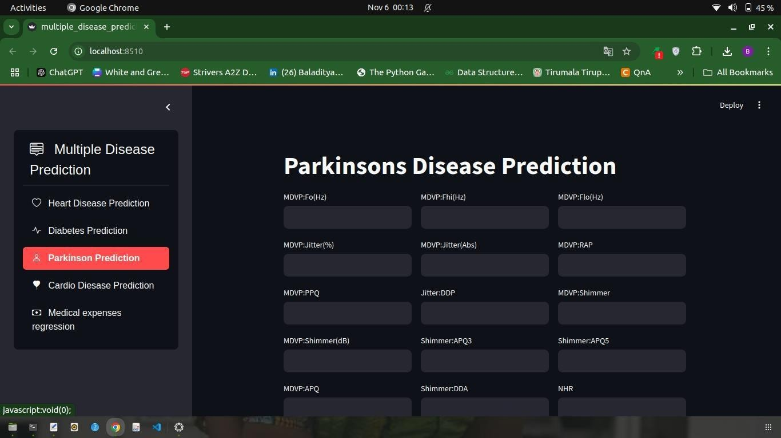

CardioDiseasePrediction:

SampleCode:

importnumpyasnp importpandasaspd importpickleimport tensorflow
fromtensorflowimportkeras
fromkeras.modelsimportSequential from keras.layers
importDense,Dropout

data=pd.read_csv("/content/cardio_tr ain.csv",sep=";")

data.head()

gender:
1->women,2->men cholesterol:
1->normal,2->abovenormal,3-
>wellabouvenormal glucose:
1->normal,2->abovenormal,3-
>wellabouvenormal smoke:
1->yes,0->no alcohol:
1->yes,0->no
active:
1->yes,0->no
cardio:
1->yes,0->no

data.info()

data.drop(columns=["id"],axis=1,inpla ce=True)

data["cardio"].value_counts() #almostsameandbalanceddataset
fromsklearn.model_selectionimport train_test_split
x=data.iloc[:,:-1]
y=data.iloc[:,-1]

from sklearn.preprocessing import
StandardScalerscaler=StandardScaler() x=scaler.fit_transform(x) x_train,x_test,y_train,y_test=train_tes t_split(x,y,random_state=2,test_size= 0.2)
print(x_train.shape,x_test.shape,y_tra in.shape,y_test.shape)

Model building pipinstall-Ukeras-tuner
model=Sequential() model.add(Dense(32,activation="relu"
,input_dim=11)) model.add(Dense(24,activation="relu"
,input_dim=11))
model.add(Dense(12,activation="relu"
))
model.add(Dense(8,activation="relu")
)
model.add(Dense(1,activation="sigmo id"))

model.compile(optimizer="rmsprop", metrics=["accuracy"],loss="binary_cr o ssentropy")
model.fit(x_train,y_train,validation_da ta=(x_test,y_test),epochs=10)

input=scaler.transform(np.array([[218 62,1,163,69.0,100,70,1,1,0,0,1]]))
model.predict(input)

pickle.dump(scaler,open("cardio_scale r.sav","wb")) model.save("cardio_model.h5")

Output:
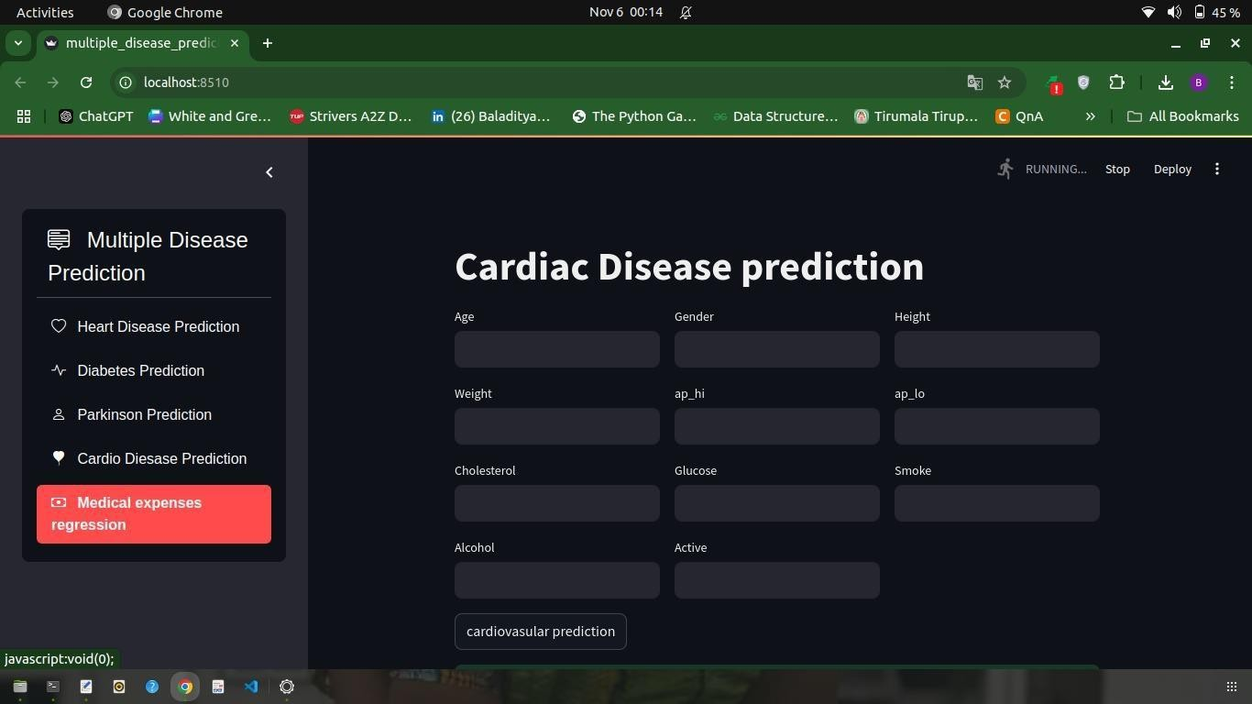

MedicalExpensesRegression:

Sample Code:

importnumpyasnp importpandasaspd
data=pd.read_csv("/content/insur ance.csv")
data.head() data.info() data.describe()
data["sex"].replace({"female":0," male":1},inplace=True)

data["smoker"].replace({"no":0,"y es":1},inplace=True) data["region"].value_counts() data["region"].replace({"southeas t":1,"southwest":2,"northwest":3
,"northeast":4},inplace=True)
data.head()

from
sklearn.model_selectio
nimporttrain_test_split x=data.iloc[:,:-1]
y=data.iloc[:,-1]

from
sklearn.preprocessin
g import StandardScaler scaler=StandardScaler() x=scaler.fit_transform(x) print(x)

x_train,x_test,y_train,y_test=train
_test_split(x,y,test_size=0.2,rand om_state=2)
print(x_train.shape,x_test.shape,y
_train.shape,y_test.shape)

from
tensorflow.keras.model
simportSequential from
tensorflow.keras.layer
s import Dense, Dropout,
BatchNormalization from
tensorflow.keras.callback
s import EarlyStopping from tensorflow.keras
importbackendasK
fromtensorflow.keras.optimizers importAdam
from tensorflow.keras.regularizers importl2

def r2_score(y_true, y_pred): ss_res=K.sum(K.square(y_true
- y_pred)) ss_tot=K.sum(K.square(y_true
- K.mean(y_true)))

return1-ss_res/(ss_tot+ K.epsilon())

model=Sequential()

model.add(Dense(128, activation="relu",
input_dim=6
,kernel_regularizer=l2(0.001))) model.add(BatchNormalization()) model.add(Dropout(0.2))

model.add(Dense(64, activation="relu", kernel_regularizer=l2(0.001)))
model.add(BatchNormalization()) model.add(Dropout(0.2))

model.add(Dense(32, activation="relu", kernel_regularizer=l2(0.001)))
model.add(BatchNormalization()) model.add(Dropout(0.1))

model.add(Dense(16, activation="relu"))
model.add(Dense(8, activation="relu")) model.add(Dense(1))

model.compile(

optimizer=Adam(learning_rate=0. 0005),
loss='mean_squared_error', metrics=[r2_score, 'mae']
)

early_stopping =
EarlyStopping(monitor='val_r2_sc ore', patience=10, mode='max', restore_best_weights=True)

history = model.fit( x_train,y_train, validation_data=(x_test,
y_test),
epochs=100,

batch_size=32,

callbacks=[early_stopping]
)

importpickle pickle.dump(scaler,open("charges
_scaler.sav","wb")) model.save("charges_model.h5")
input=np.asarray([53,0,28.1,3,0,2]
)
input=scaler.transform([input]) model.predict(input)

Output:
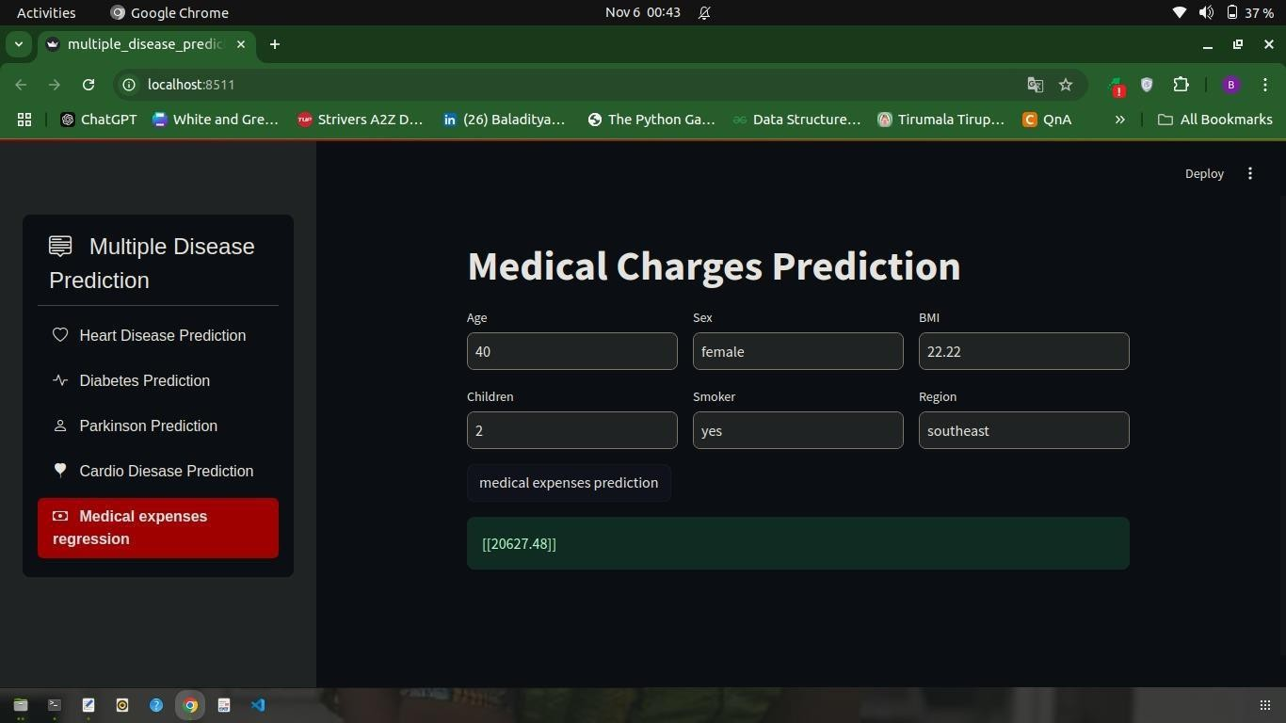

TESTING
UnitTesting

Testing ividualfunctionsormodulesresponsibleforthepredictionofeachdisease.

HeartDiseasePrediction:
  - Validateinputfeaturepreprocessing(e.g.,cholesterollevels,blood pressure).
  - Testthepredictionfunctiontoensureitoutputsexpectedcategories(e.g., "No Disease,""High Risk").
  - Testboundaryvalues(e.g.,borderlinecholesterollevels).

DiabetesPrediction:
  - Ensureinputvalueslikeglucoselevels,BMI,andagearecorrectlyprocessed.
  - Testformissingorabnormalvaluesinfeaturesandensurethesystem handles them properly.

Parkinson'sDiseasePrediction:
  - Testpreprocessingforspeech-relatedfeatures(e.g.,jitter,shimmer).
  - Verifythattheoutput(e.g.,"DiseasePresent"or"NotPresent")alignswiththe test data.

MedicalExpensesPrediction:
  - Validatenumericalpredictionsofexpensesusingtestdata.
  - Testforextremevalues(e.g.,veryhighorverylowexpenses).

CardioDiseasePrediction:
  - Testdatapreprocessingsteps(e.g.,scalingofbloodpressure,age normalization).
  - Ensurethatriskscoresorclassificationlabelsmatchexpectedresults.

CONCLUSION
InConclusion,TheMultipleDiseasePrediction systemcombinesmodelsforheart disease,diabetes,Parkinson'sdisease,cardiodisease,andmedicalexpenseprediction into a unified platform. Rigorous testing, including unit, integration, functional, performance, and security tests, ensures accuracy, efficiency, and reliability. By addressing edge cases, ensuring seamless integration, and maintaining user- friendliness,thesystemisdesignedto providedependablepredictions, handled iverse inputs, and deliver actionable insights, making it a valuable tool for proactive healthcare management.

FUTUREENHANCEMENT
- ExpandedDiseaseCoverage:Integratepredictionforadditionaldiseasestomakethe system more comprehensive.
- PersonalizedInsights:Incorporatepatienthistoryandlifestyledataformore tailored predictions.
- ExplainableAI:Addinterpretabilityfeaturestoexplainmodelpredictionsforbetteruser understanding.
- Real-TimeMonitoring:Enableintegrationwithwearabledevicesforcontinuous health tracking.
- Multi-LanguageSupport:Makethesystemaccessibletoawideraudiencebyadding multi-language options.
- DeploymentScalability:Upgradetheplatformtohandlehighertrafficandreal-timeAPI integration.
- ImprovedAccuracy:Utilizeadvancedmodelslikeensemblelearningortransformersfor better prediction accuracy.
- TelemedicineIntegration:Linkpredictionswithtelehealthplatformsforinstant consultations.
- EnhancedSecurity:Strengthendataprivacywithencryptionandsecureuser authentication.
- MobileApplication:Developamobile-friendlyversionforwideraccessibility.

.

BIBLIOGRAPHY

Books:
  - Hastie,T.,Tibshirani,R.,&Friedman,J.TheElementsofStatisticalLearning:Data Mining, Inference, and Prediction. Springer, 2009.
  - Goodfellow,I.,Bengio,Y.,&Courville,A.DeepLearning.MITPress,2016.

ResearchPapers:
  - Pedregosa,F.,etal."Scikit-learn:MachineLearninginPython."Journalof Machine Learning Research, vol. 12, 2011, pp. 2825-2830.
  - Ghate, S., et al. "Machine Learning Techniques for Disease Prediction: A Review."InternationalJournalofEmergingTrendsinEngineeringResearch,vol. 8, no. 7, 2020, pp. 4014-4020.

WebResources:
  - StreamlitDocumentation."BuildingInteractiveMachineLearningApps."www.streamlit.io, accessed November 2024.

Datasets:
  - Kaggle."DiabetesDataset,"www.kaggle.com.
  - Parkinson'sSpeechDataset,www.kaggle.com.

